17 W. South ST, Greenfield IN (317) 477-4430

GREENFIELD FIRE TERRITORY

2024 4th Quarter Write-Offs

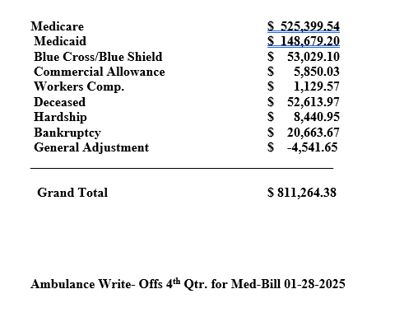

2024 Year End Totals

TOTAL INVOICED - $5,079,814.11
TOTAL WRITE-OFFS - $3,375,381.11
TOTAL RECEIPTS - $1,653,511.71

