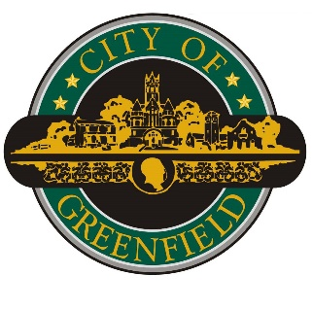

November 17, 2025

Mayor Titus
Greenfield Board of Public Works and Safety
10 S State Street
Greenfield IN 46140

Re: City Attorney Contract

Dear Board of Works Members,

I respectfully request your approval of the City Attorney’s 2026 contract. The sole revision from the 2025 agreement is an adjustment to scheduled unpaid leave, increasing from 20 days to 25 days.

Thank you for your consideration.

Respectfully,

Mitchael W. Ripley
HR Director
City of Greenfield

