January 21, 2026

RE: Planning Department – Request for Mowing Bids

Mayor and Board Members,
The Planning Department is requesting permission to send out a mowing bid packet to get contractors secured for our code violations for 2026. A copy of the main portion of the bid packet has been included with this request for your information.
Thanks,
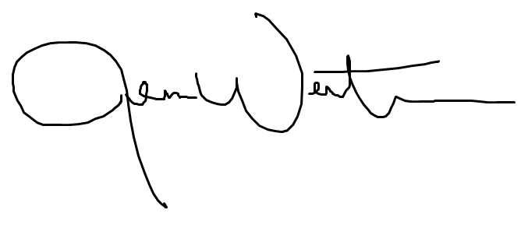
Jenna Wertman, AICP | CPM
Planning Director

