February 18, 2026

RE: Planning Department – Request to Open Mowing Bids

Mayor and Board Members,
The Planning Department is requesting that submitted mowing bids be opened during the February 24th Board of Works meeting.
Thanks,
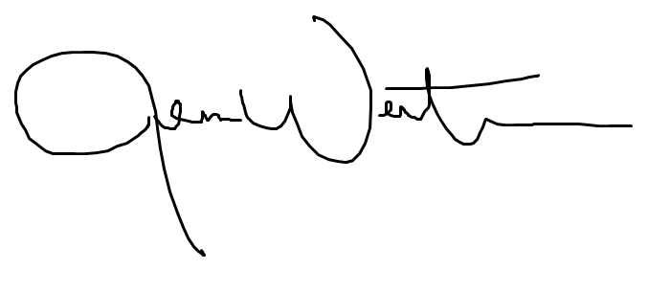
Jenna Wertman, AICP | CPM
Planning Director

