May 19, 2026

Board of Public Works & Safety

RE: Employee Pay Increases

Members:

I am requesting pay increases for various employees. After review of employee files, the following employees have never been bumped up to their full pay rate. Each is passed their entry/probationary period and has completed varying degrees of training and classes for their roles (including those employees that have switched roles over time). Examples include:

- Donna Butler: Donna has served in building and planning roles in her tenure here and continues to do trainings and classes for both. She has also provided direct assistance to me for the Brownfields Grant administration and handles the Board of Zoning Appeals. I would request that her pay be increased to $35.71 per hour. She has been in the Associate Planner position for multiple years.
- Evan Beaty: Evan completes various training and planning conferences per year. He is the primary staff member for Plan Commission cases and Historic Board. I would request that his pay be increased to $35.71 per hour. Evan has been in the Associate Planner position for multiple years.
- Andrew Adkins: Andrew is the primary reviewer for residential permits, does various inspections, and takes multiple building training courses each year. I would request that his pay be increased to $34.62/hour. He has been in his position for multiple years.
- Mark Dungan: Mark has been with the city just over one year and attends the building courses for training. He reviews fence permits, code compliance cases, and has passed his probationary period. I would request his pay be increased to $34.62/hour.

Employees not mentioned above are at their full pay range and are not part of this request.

Thank you.

Respectfully,
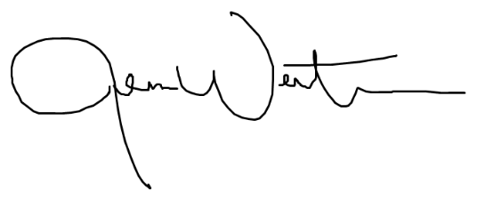

Jenna Wertman, Planning Director

