COA26-01 23 W North St, Twenty Main LLC, is proposing an exterior remodel of the historic building located between the Wooden Bear and Living Alley along W North St.
Exhibits:
- Plans and Renderings
- Current Conditions Pictures

Location and Surrounding Uses:
North DT Downtown & Historic District – Commercial & Park (Riley Arts Trail)
South DT Downtown & Historic District – Commercial
East DT Downtown & Historic District – Commercial
West DT Downtown & Historic District – Parking Lot & Park (Living Alley)

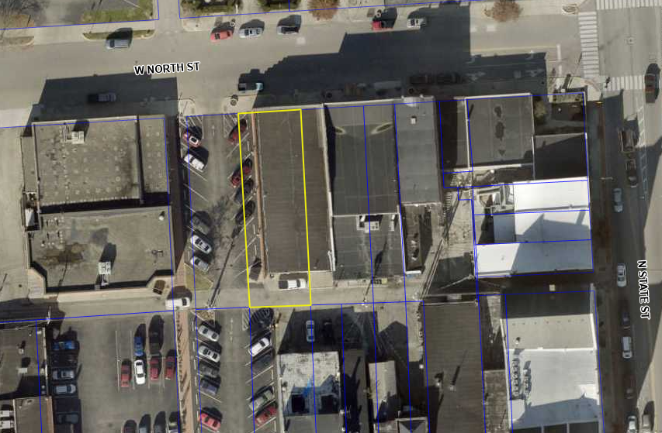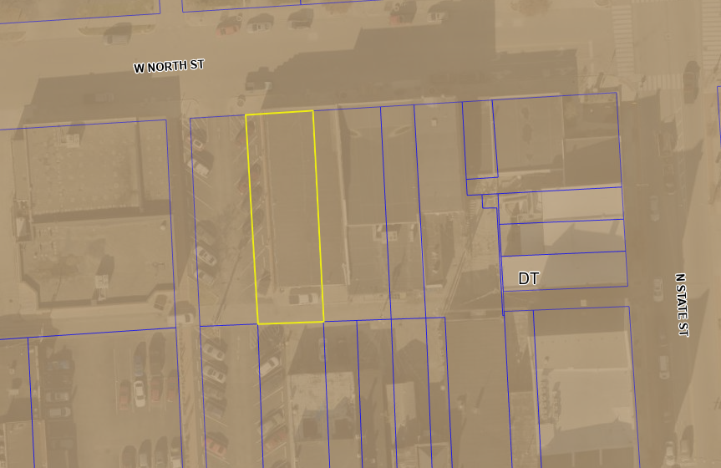
Aerial Site Location Zoning Site Location

CURRENT CONDITIONS

The building is located prominently along the Riley Arts Trail, across from the street from the iconic Carnegie’s restaurant, as well as between the popular Wooden Bear Brewery and Living Alley art installation. This location and its visibility from both Main Street and North Street make the current dilapidated state of the building’s exterior a notable blemish on Greenfield’s Downtown, especially with it being along the recently completed Riley Arts Trail.

The building’s construction dates to somewhere between the late 1800’s and the early 1900’s and it has been purportedly used as a garage and general storage over the years. It has sat unoccupied in a state of disrepair for decades. The building was recently purchased by the petitioners in 2024, which is when they began the process of securing and repairing it. The roof repairs were recently completed along with some of the work along the rear of the building. However, the rest of the building’s exterior is still in need of significant repairs to the doors, windows, siding, and brickwork.

Current Proposal

The Petitioner proposes to replace all exterior doors and windows as shown in the exhibits. This includes replacing one of the current doors on the front of the building with a larger window, more closely reflecting how the building previously looked years ago. The brickwork throughout the building will be repaired, restored, and replaced as necessary with the intention of preserving the existing brickwork wherever possible. The doorway to the west which faces the parking lot on the Living Alley will necessitate one of the parking spaces in to be blocked off with stripes and bollards to allow access. This change to the parking lot has conceptually been approved by various city departments and officials and will be done at the petitioner’s expense.
Historic Board – COA
Per the Historic Preservation Code 155.10.F, “Certificates of appropriateness shall be granted if the Historic Board determines that the proposed action is not obviously incongruous with the historic district and shall not be granted if the proposed action is obviously incongruous with the historic district. In determining whether a particular proposal is obviously incongruous with the historic district, the Historic Board shall take into account the purposes of this chapter, the visual compatibility standards contained in this chapter, the historic and architectural significance of the structure and the effect of the proposed change in diminishing or enhancing the significance, the effect of the proposed change on the streetscape, the effect of the proposed change on surrounding structures, and the effect of the proposed change on the district as a whole. The Historic Board shall act in a manner which preserves the visual aspects of the architectural and historic character of the district by assuring that obviously incongruous changes are not allowed.”
This location is highly visible and in a heavily traveled area within the heart of the city. The building itself is in one of the more prominent locations along the Riley Arts Trail and the Living Alley. Repairing the building’s exterior and activating its use would be a boon to the whole of the Downtown district. The particulars proposed under this petition closely align with both the historic nature of the building and its neighbors, enhancing both the cohesive aesthetic of the area and the historic authenticity of the buildings collectively.
Staff finds that the repairs and remodels proposed under this petition are appropriate, that they align with both the specific and general design guidelines for the historic district, and that these repairs will greatly enhance the beauty of the district by remediating a dilapidated building in a prominent location.

Staff Recommendation: Approve the COA request based on the submitted images, subject to the findings in the staff report, and the following conditions:

- Exterior paint(s) and materials shall be installed and / or applied using appropriate materials and methods to minimize damage done to and ensure the protection and preservation of the existing façade, stonework, or masonry.
- The paint, bollards, and any other appropriate work or materials required for the blocking off with of any parking space(s) within the adjoining city-owned parking lot to accommodate the west-facing door of the property at 23 W. North St. shall be provided by and completed at the Petitioner’s expense.

