Greenfield Engineering & Planning
MEMORANDUM
To: Traffic Safety Committee
From: Glen Morrow, City Engineer
Date: October 31, 2025
Re: Evaluation of Speed Tables – 1600 Block of Melody Lane

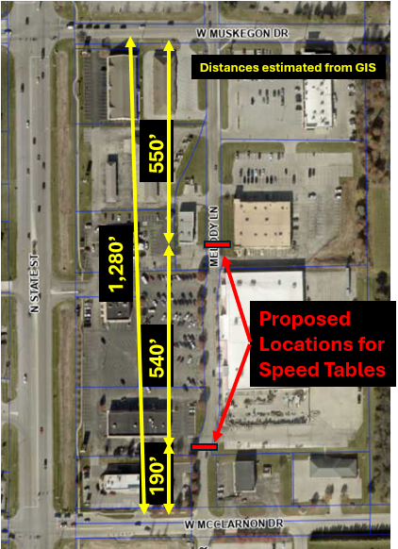
Purpose
The purpose of this memorandum is to evaluate the number of speed tables proposed for the 1600 block of Melody Lane. At the December 2025 meeting, a resident expressed concern that two speed tables may be insufficient to adequately address vehicle speeds along this block.

Applicable Design Guidance
Guidance regarding the design and spacing of speed tables was reviewed from resources published by the Federal Highway Administration, including the Institute of Transportation Engineers (ITE) Guidelines for the Design and Application of Speed Humps. These guidelines recommend spacing speed humps or speed tables between 260 and 500 feet. Several jurisdictions have refined these recommendations further, including:
- Pennsylvania: Spacing between 250 and 600 feet
- South Carolina: Minimum spacing of 350 feet
- Virginia: Approximately 500 feet spacing, with a minimum of 200 feet of clear visibility and placement no closer than 200 feet from an intersection
- Pasadena, California: Speed humps only on street segments at least 1,200 feet in length, with traffic signals or stop signs spaced no closer than 1,200 feet apart

Proper placement of the first speed table in a series is also critical. The ITE guidelines state that “the first speed [table] in a series is normally located in a position where it cannot be approached at high speed from either direction.” To achieve this, speed tables are typically installed within 200 feet of a small-radius curve or stop sign, or at the top of a hill where a significant downgrade exists.

It should be noted that neither the State of Indiana nor the City of Greenfield has adopted refined local guidelines for speed table spacing beyond the general ITE recommendations.

Proposed Locations and Evaluation
The two proposed speed table locations shown in the exhibit were initially selected to encompass the full extent of shopping center-related activity while avoiding conflicts with driveways and parking aisles.

The proposed southern speed table is approximately 190 feet north of the intersection with W. McLarnon Drive, and the northern speed table is approximately 550 feet south of the intersection with W. Muskegon Drive. Both distances are consistent with the referenced design standards.

The spacing between the two proposed speed tables is approximately 540 feet, which slightly exceeds the ITE upper recommendation of 500 feet but remains consistent with spacing standards used by jurisdictions that have adopted refined guidelines.

Following a site visit and evaluation of pedestrian traffic patterns, staff attempted to identify a suitable location for a third (middle) speed table. However, no location was identified that would be feasible without creating additional concerns. A middle speed table would likely present increased tripping hazards, particularly due to its proximity to pedestrian movements and the need to blend with existing sidewalks and curb ramps along the east side of Melody Lane. Constructing such transitions without introducing tripping hazards would be difficult.

Recommendation
Based on the review of applicable guidelines, site conditions, and pedestrian safety considerations, it is recommended that the project proceed with two speed tables as currently proposed. A third, middle speed table may be reconsidered in the future if the two installed speed tables, along with other implemented traffic-calming measures, do not achieve the desired reduction in vehicle speeds along Melody Lane.

Module 3: Toolbox of Individual Traffic Calming Measures Part 2 | FHWA

